This graph shows the number of survived people group by gender. It is obvious that the number of female is two times more than male. The reason may be that women are more likely to be taken care of and have opportunities to run their lives. So “sex” is a good predictor when we are doing analysis.

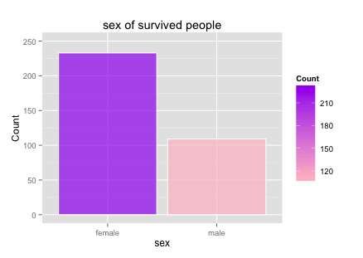

This graph shows the relation between passenger class and whether they are survived. It is obviously that passengers in 2nd and 3rd class were less likely to die, as first class cabins were closer to the deck of the ship.

